

**ICT DEPARTMENT**

**DEVELOPMENT OPERATIONS (ITLDO801)**

**CAT PRATICE**

**NIYIGABA Claude**

**Reg no: 24RP14647**

Q1 index.php

Code:

Figure q1

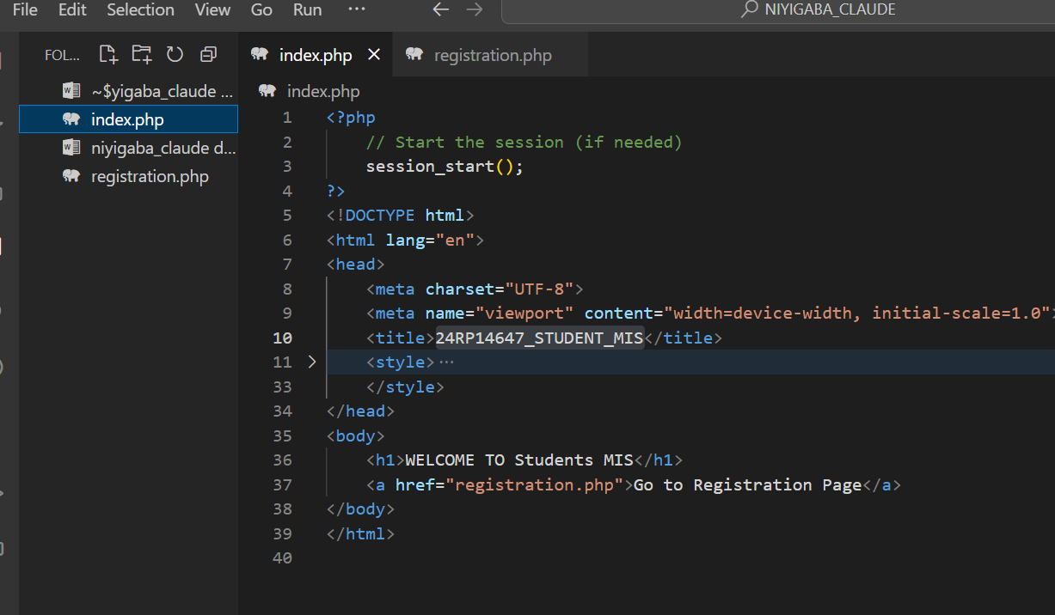

Output: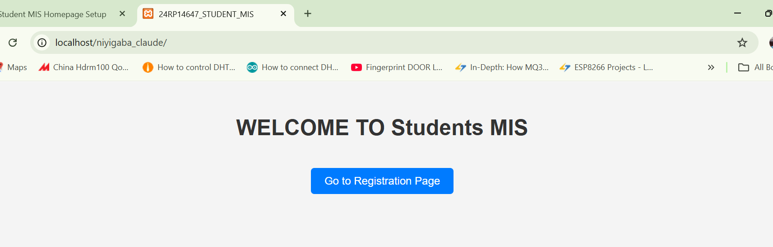

Q2. Commit index.php page

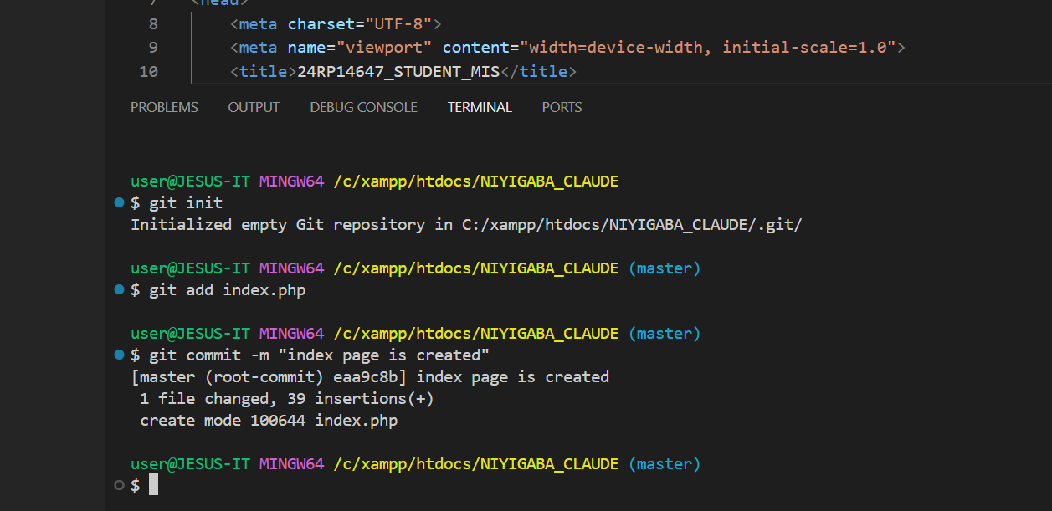

Figure : Commit index.php page

Q3. Create registration page

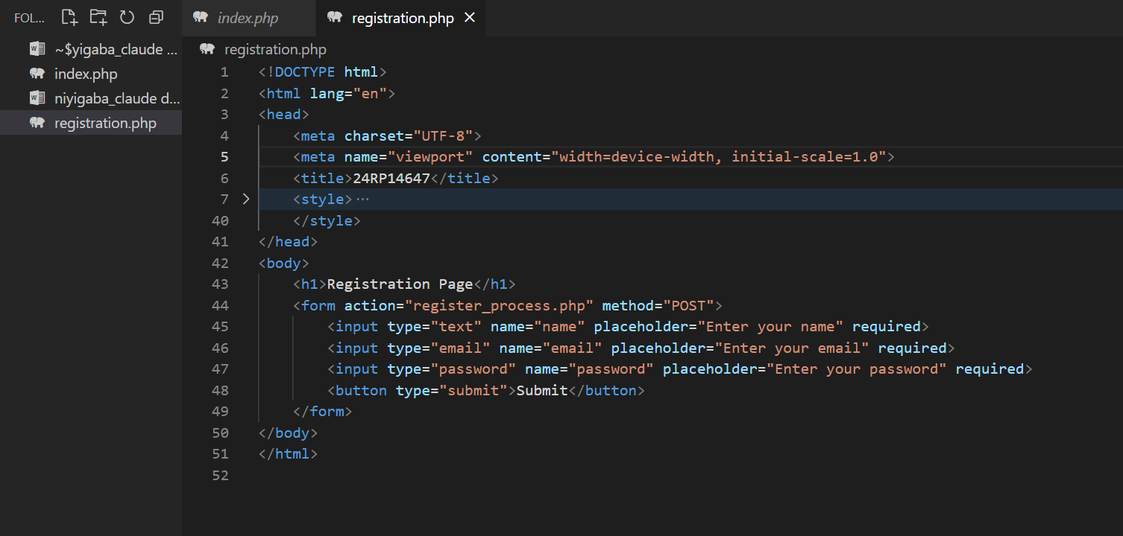

OUTPUT OF REGISTRATION PAGE

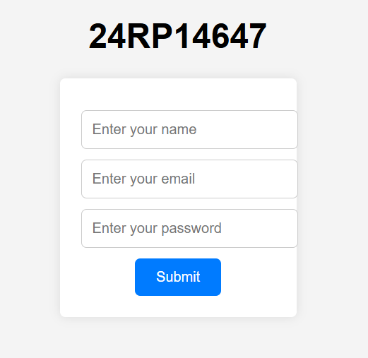

Add new branch as add-form-branch

Code: git branch add-form-branch and show available: git branch

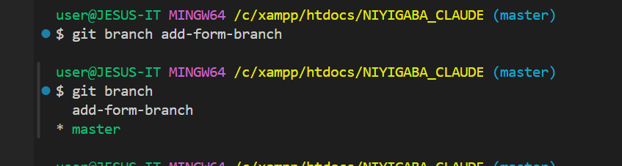

Q4. Commit registration form addition

Code used to commit:

git checkout add-form-branch

git add registration.php

git commit -m "24rp14647, the form is added successfully"

OUTPUT:

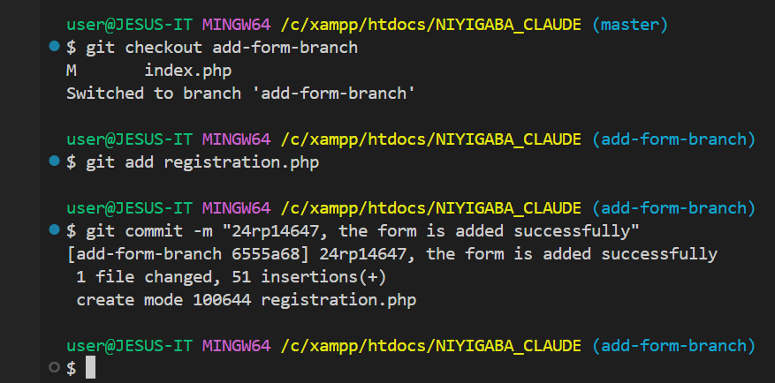

Q5 merge code:

* git checkout master
* git merge add-form-branch

OUTPUT:

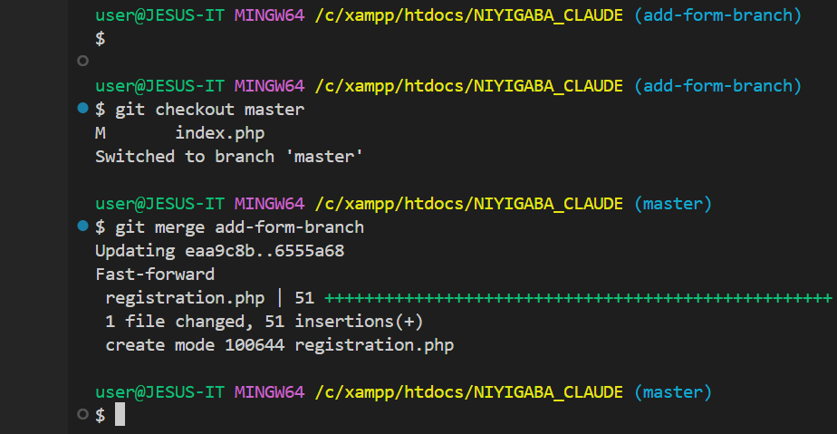

Q6.

Git branch bootstrap

Git add index.php registration.php

Code:

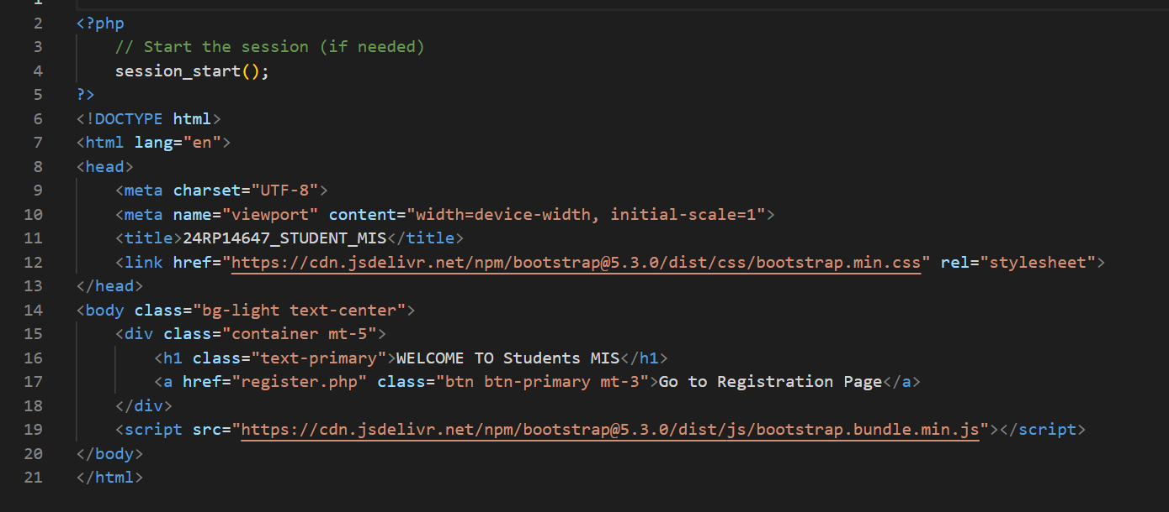

Output:

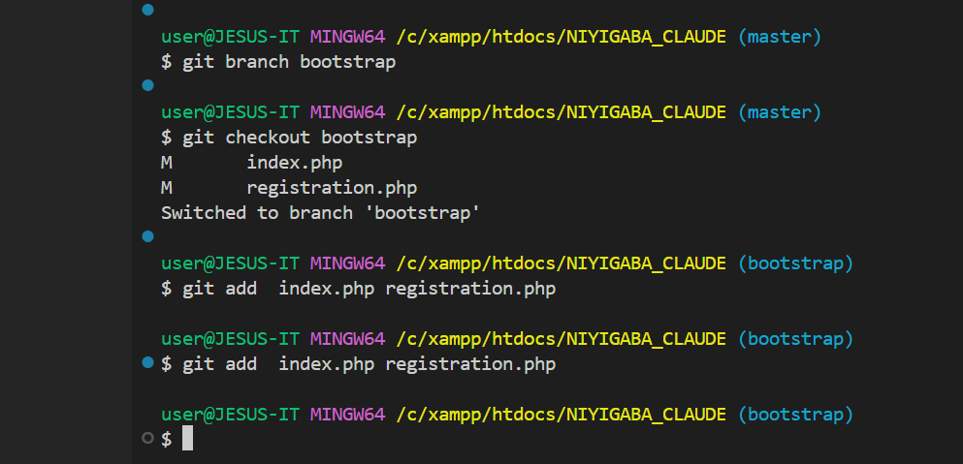

Q7. **Code**: Git commit –m “24rp14647 the bootstrap is added”

Output:

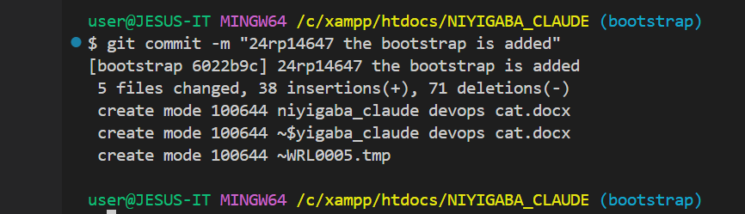

Q8 merge code : git merge bootstrap

Output:

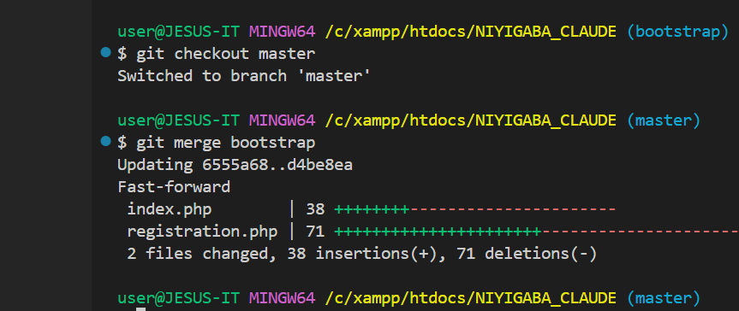

Q9 <https://github.com/claudejesus/24rp14647>

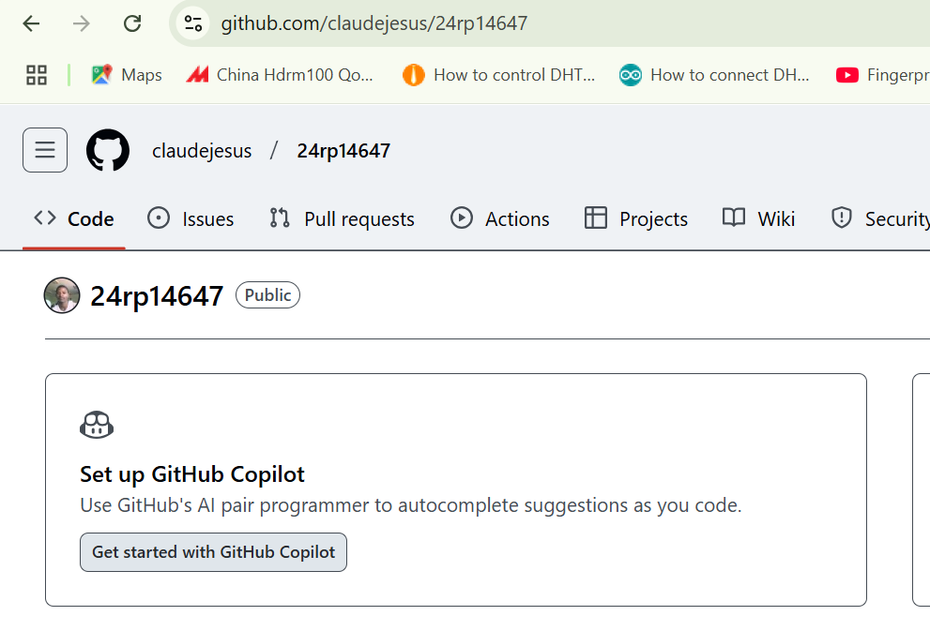

Q10. Dockerization

Dockerfile:

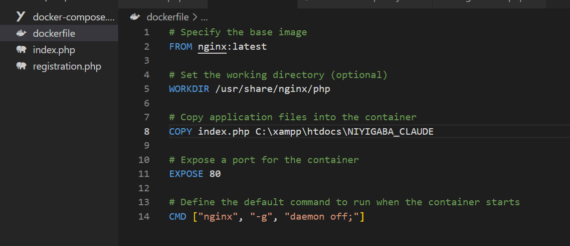

Docker-compose.yml:

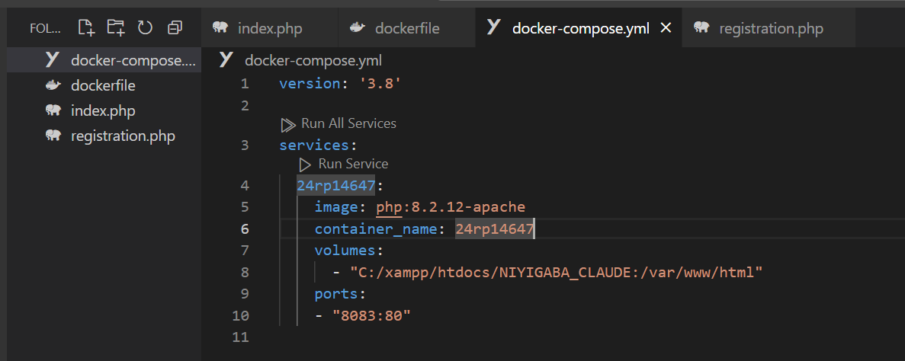

Code of build webapplication used docker-compose.yml:

Q11. Testing

Docker image



Docker container with port

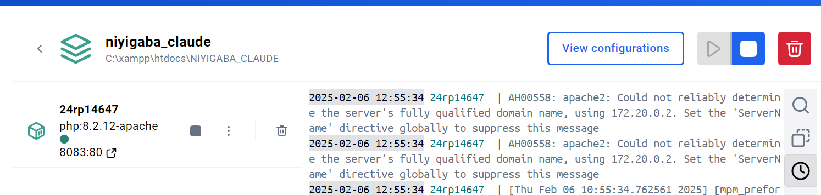

Docker web

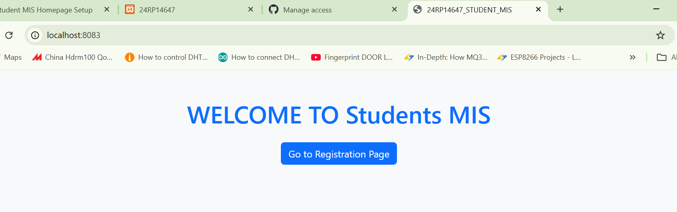

Registration page test from docker:

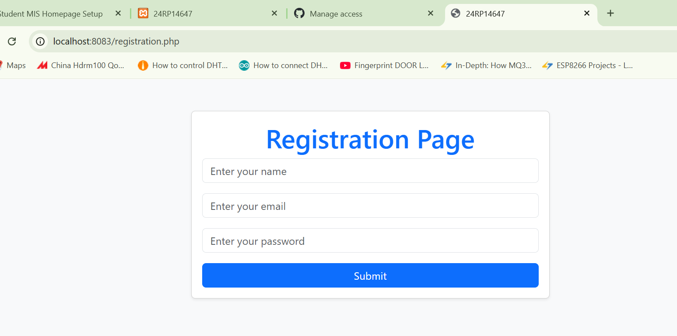

Q12 push to git hub

Code:

* git remote add origin https://github.com/claudejesus/24rp14647.git
* git branch -M main
* git push -u origin main

output:

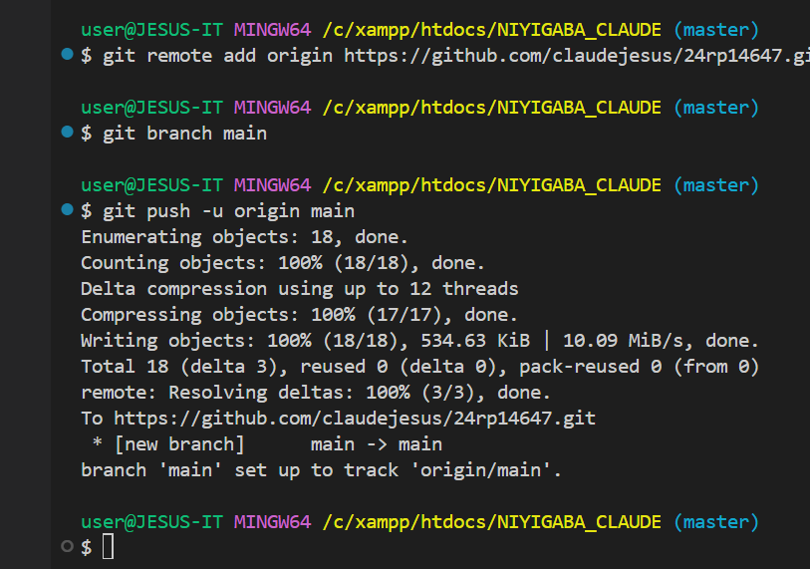

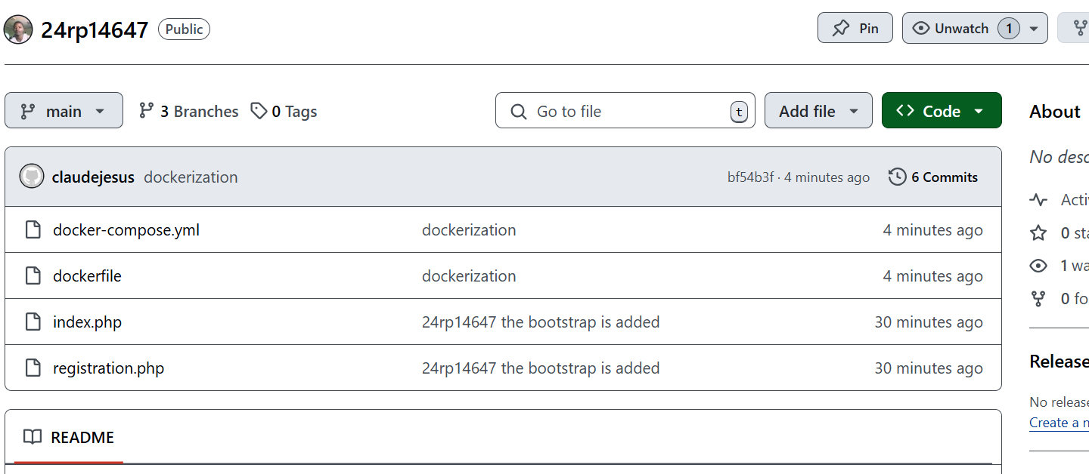

Q13 collaboration: to [bucyanny@gmail.com](mailto:bucyanny@gmail.com)

